Counselling centred around you
Roisin Elder BA PG Dip Couns MBACP
Person-centred counselling in Norwich | For anxiety, depression, stress, panic attacks, bereavement | Specialising in sexual abuse, childhood sexual abuse and the traumas resulting from them | Panic attacks or spiritual crisis | Mindfulness meditation techniques
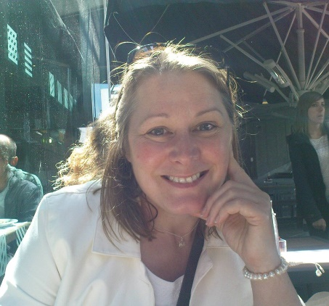
Contact: counselling@roisinelder.com
I aim to create a gentle, non-judgemental welcome for you to bring your most personal thoughts and feelings in total confidence. I can help you to navigate your most personal issues in your own way in complete confidence, at your own pace and as far as you feel you want to.
If you are considering talking with someone about things that are becoming too difficult to endure by yourself, you may find that my compassionate, empathic style of listening and counselling is helpful to gently work with even the most sensitive issues.
My Approach
I work in a person-centred way based on empathetic listening and non-judgemental reflection. By being completely open to your unique experience I can help you find your way forward in your unique situation.
How it works
The person centred approach prioritises understanding, compassion, and acceptance, allowing the development of new awareness, realisations and acceptance which helps new solutions to emerge.
Building a trusting therapeutic relationship is key to achieving personal change, so your choice of therapist is important. You can find out more about how I work with an introductory session.
I also specialise in working with women and men suffering from rape, sexual abuse, childhood rape and sexual abuse and the ongoing traumas and difficulties that occur as a result.
I work at Mind, The Sue Lambert Trust https://www.suelamberttrust.org/ and Ormiston Families https://www.ormiston.org/ Please see my website to find out more about how I work: http://www.roisinelder.com/
I am registered at The British Association for Counselling and Psychotherapy (BACP) where you can also find my advertised listing. www.bacp.co.uk is one of the main UK professional bodies and I adhere to their updated code of ethics and practice.
Frequently asked Questions:
Q. How many counselling sessions do I need?
A. It depends. Some people find adequate peace of mind after a couple of months of sessions with a counsellor, others have a lot of things to share and need longer. Some people come regularly at first and and then come back for a session every now and then. Others may work with a counsellor for a year or more.
A big factor in therapeutic change is the open and trusting relationship you have with your counsellor, and your own sense of what you want to achieve. That can take a few sessions to establish. Everyone is different.
Six sessions is generally accepted to be a minimum space for any kind of therapeutic work. It is because longer is often required that I offer some discount for mid term and long term work.
Q. How long are sessions and are they regular? Can I park nearby?
A. There is free parking. Each session is 50 minutes, they are regular. It is accepted practice that once weekly is ideal. Some organisations will not accept fortnightly patterns. I suggest weekly for the first 8 weeks to build momentum, with a review after that.
Q. Is counselling completely confidential?
A. Yes. It is completely confidential. I am bound by a professional code of ethics and I will never tell anyone what you tell me, apart from my supervisor who is also bound by these ethics. All counsellors have to have supervisors.
Nobody knows you are having counselling and there are no notes with your name or any identifying information. I never keep notes unless you ask me to, in which case anonymous (coded) notes will kept in a locked filing cabinet. You can ask to see them any time.
If there is a risk to safety for yourself or anyone else, I will bring this up with you and we can discuss whether anyone else, like a doctor, might need to know.
Q. Do I really need to see a counsellor or therapist? I’ve never had mental health problems. I don’t think there’s anything wrong with me, I just feel awful.
A. Counselling and psychotherapy is for anyone who feels they might benefit from talking to a professional therapist about the problems they are facing. Sometimes issues might seem small on the surface but then start to feel overwhelming as they can affect other parts of our lives without us realising it straightaway. We may notice a change in our sleep pattern and/or appetite. We may feel increasing mood swings, or lack energy; perhaps we are finding it difficult to focus at work or around our friends and family. We may feel less pleasure in the things that we have previously enjoyed and start not to feel like ourselves anymore.
These are all early warning signs that tell us something isn’t quite right and it is at this point that we either hope things will start to get better soon or reach out for help.
Early intervention is key to feeling better about ourselves sooner, as often issues escalate into bigger issues without help and support.
Q. Do I need to know anything about counselling or psychology?
A. No. In fact sometimes it’s better if you don’t – then you can stay with your own experience without diverting into theories.
Q. Can you tell me how to fix my problems?
A. I can’t, and wouldn’t tell you how to fix anything. I will help you to find the way to take care of your problems, and help you find your own solutions if that’s what you want to do.

