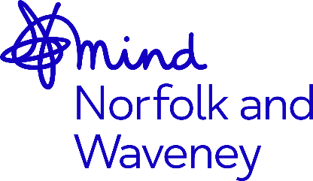
Nature Connect Registration Form

Thank you for your interest in taking part in the Nature Connect Project.
Nature Connect is about getting closer to nature with other like-minded people to become more resilient and improve our wellbeing through everyday outdoor activities.
Nature Connect is suitable for people over 18 with mild to moderate mental health conditions, such as depression and anxiety, or who feel at risk of developing them. If you have any queries about whether this is the right project for you, please contact natureconnect@norfolkandwaveneymind.org.uk
☐ I agree that my details may be shared confidentially with our external evaluators Bright Purpose for the purposes of monitoring. This is to determine the effectiveness of the project and may include a follow up survey once the project has ended. (Please tick if you agree).

☐ Can we keep you informed about our future Nature Connect events? This will include free courses, workshops, groups and taster sessions. We will only contact you when these opportunities become available. We won’t pass on your details to any external parties. Please tick the box if you are happy for us to use the information you have provided for this purpose.

About you
First name | Click here to enter text.
Surname | Click here to enter text.
Gender | Click here to enter text.
Date of Birth | Click here to enter a date.
Address | Click here to enter text.
Postcode | Click here to enter text.
Email address | Click here to enter text.
Telephone number | Click here to enter text.
How do you prefer us to contact you?
About you

Do you have any physical disabilities, long-term illness or special needs which would help us to know about, to help you participate fully in the session? (please give details)

Click here to enter text.
Outdoors Activity
Please consider any sport, fitness and recreation activities, including walking or cycling for any purpose that you have done in the past week: how many minutes have you spent outdoors? (We ask this to help us adapt our activities for all levels of fitness)
Please tick | ☐ 0 – 29 | ☐ 30 – 59 | ☐ 60 – 89 | ☐ 90 – 119 | ☐ 120 – 149 | ☐ 150+
How did you find out about the Nature Connect project? (please tick as many as apply)
Newspaper | ☐ | Word of mouth | ☐
Leaflet | ☐ | Newsletter | ☐
Email | ☐ | Internet Search | ☐
Social media (Facebook etc) | ☐ | Poster | ☐
Referral from surgery via social prescribing service |  |  | ☐
Referral via another organisation (please tell us which) |  |  | ☐
Why did you decide to take part? (Please tick)
To be more active/healthy | ☐
To meet new people/socialise | ☐
To try new activities I haven’t done before | ☐
To improve my mental health/wellbeing | ☐
To get more involved in my local community | ☐
Other (Please Specify) Click here to enter text. | ☐

I understand that by signing below, I give consent to Norfolk and Waveney Mind to record and process my data in accordance with GDPR legislation. N&W Mind’s Privacy Policy can be found at http://www.norfolkandwaveneymind.org.uk/getdoc/532cce00-5bfa-43ef-9f26-34c723ceaf8e/privacy-statement

Signed: _______________________ (Can be typed) Date: _______________________

Thank you for completing this form – please return to natureconnect@norfolkandwaveneymind.org.uk as soon as possible and we will confirm as soon as we can, whether we can offer you a place.

