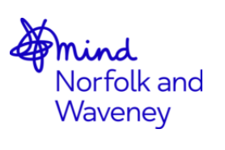

Please complete this form in full and return it to training@norfolkandwaveneymind.org.uk

Course Name:
Course Date:
Please list any other relevant Mental Health related training you have completed:
Please let us know if you have had any recent work/personal experience/bereavement related to suicide in the last 12 months.
Do you have any special requirements in order to attend a course?

Delegate booking details
First name:
Surname:
Preferred pronoun:
Employer:
Job Title:
Telephone number:
Email address:
Postal address:
Emergency contact on the day:

Thank you for returning your booking form.

We may suggest alternative, more suitable training based on your answers.

Terms & Conditions

Cancellation

Please ensure you inform the training team with a weeks’ notice if you are unable to attend. If the course does not meet the minimum requirements it will have to be cancelled at a cost to the charity. We understand that emergencies happen, but if you do not attend on the day without a valid reason you may be charged for the training costs.

QPR Gatekeeper Training - £50

Suicide Responders - £75

ASIST - £150

Course evaluation and certificates

We value your evaluation feedback at the end of each course so that we can ensure a high standard of delivery and content. If you are attending an MHFA, ASIST or QPR course this is fully certificated and once you have completed the course your certificate will be sent to you directly. Please note that this may take up to 4 weeks.

